Random Error
# Source: AI Source: Provided by: [Data Path: Persons Table -> ID Column: 1, Name_En Column: Motasem Essam] -> From: [ChatGPT] on [7/17/2026]
Random Error is a type of measurement error that causes unpredictable variations in repeated measurements of the same quantity under identical conditions. Unlike systematic errors, random errors do not have a consistent direction or magnitude. They may cause measurements to be higher or lower than the true value in an irregular manner.
Random errors are unavoidable in all real-world measurements and primarily affect the precision (repeatability) of measurements.

Definition
# Source: AI Source: Provided by: [Data Path: Persons Table -> ID Column: 1, Name_En Column: Motasem Essam] -> From: [ChatGPT] on [7/17/2026]
Random Error is the unpredictable variation in measured values caused by uncontrollable or unknown factors that produce small, irregular differences between repeated measurements of the same quantity.

Purpose of Studying Random Errors
# Source: AI Source: Provided by: [Data Path: Persons Table -> ID Column: 1, Name_En Column: Motasem Essam] -> From: [ChatGPT] on [7/17/2026]
Understanding random errors helps to:
- Evaluate measurement precision.
- Estimate measurement uncertainty.
- Improve repeatability.
- Analyze experimental data.
- Increase confidence in measurement results.
- Reduce variability in manufacturing and scientific measurements.

Characteristics
# Source: AI Source: Provided by: [Data Path: Persons Table -> ID Column: 1, Name_En Column: Motasem Essam] -> From: [ChatGPT] on [7/17/2026]
Random errors:
- Are unpredictable.
- Vary in magnitude.
- Vary in direction (positive or negative).
- Affect precision more than accuracy.
- Cannot be completely eliminated.
- Can be reduced by repeated measurements and statistical analysis.

Example
# Source: AI Source: Provided by: [Data Path: Persons Table -> ID Column: 1, Name_En Column: Motasem Essam] -> From: [ChatGPT] on [7/17/2026]
Suppose the true length of a metal rod is:
True value = 100.00 cm
Repeated measurements:
- 99.98 cm
- 100.03 cm
- 99.99 cm
- 100.01 cm
- 100.02 cm
The measurements fluctuate slightly around the true value with no consistent pattern. These variations are caused by random error.

Causes of Random Error
# Source: AI Source: Provided by: [Data Path: Persons Table -> ID Column: 1, Name_En Column: Motasem Essam] -> From: [ChatGPT] on [7/17/2026]
Random errors may result from:
Instrument Limitations
- Limited instrument resolution.
- Electronic noise.
- Mechanical vibration.

Environmental Variations
# Source: AI Source: Provided by: [Data Path: Persons Table -> ID Column: 1, Name_En Column: Motasem Essam] -> From: [ChatGPT] on [7/17/2026]
- Temperature fluctuations.
- Humidity changes.
- Air pressure variations.
- Wind or vibration.
- Electrical interference.

Observer Variations
# Source: AI Source: Provided by: [Data Path: Persons Table -> ID Column: 1, Name_En Column: Motasem Essam] -> From: [ChatGPT] on [7/17/2026]
- Human reaction time.
- Small differences in reading scales.
- Slight differences in positioning.

Natural Variability
# Source: AI Source: Provided by: [Data Path: Persons Table -> ID Column: 1, Name_En Column: Motasem Essam] -> From: [ChatGPT] on [7/17/2026]
- Small uncontrollable changes in the measured object or process.
- Inherent fluctuations in physical systems.

Identifying Random Errors
# Source: AI Source: Provided by: [Data Path: Persons Table -> ID Column: 1, Name_En Column: Motasem Essam] -> From: [ChatGPT] on [7/17/2026]
Random errors are identified by:
- Repeating measurements under the same conditions.
- Observing scatter among the measured values.
- Calculating statistical measures such as:
  - Mean
  - Variance
  - Standard deviation

Reducing Random Errors
# Source: AI Source: Provided by: [Data Path: Persons Table -> ID Column: 1, Name_En Column: Motasem Essam] -> From: [ChatGPT] on [7/17/2026]
Random errors can be reduced by:
- Taking multiple measurements.
- Calculating the average (mean) of repeated measurements.
- Using higher-quality instruments.
- Improving instrument resolution.
- Controlling environmental conditions.
- Using consistent measurement procedures.
Although random errors can be reduced, they cannot be completely eliminated.

Applications
# Source: AI Source: Provided by: [Data Path: Persons Table -> ID Column: 1, Name_En Column: Motasem Essam] -> From: [ChatGPT] on [7/17/2026]
Random error analysis is essential in:
- Physics
- Chemistry
- Engineering
- Manufacturing
- Medicine
- Electronics
- Metrology
- Surveying
- Scientific research
- Quality assurance

Everyday Examples
# Source: AI Source: Provided by: [Data Path: Persons Table -> ID Column: 1, Name_En Column: Motasem Essam] -> From: [ChatGPT] on [7/17/2026]
Examples include:
- Slight variations when repeatedly weighing an object.
- Small differences in repeated body temperature readings.
- Stopwatch measurements affected by reaction time.
- Minor fluctuations in electronic sensor readings.

Common Mistakes
# Source: AI Source: Provided by: [Data Path: Persons Table -> ID Column: 1, Name_En Column: Motasem Essam] -> From: [ChatGPT] on [7/17/2026]
- Confusing random errors with systematic errors.
- Assuming random errors always indicate faulty instruments.
- Believing a single measurement is sufficient.
- Ignoring statistical analysis.
- Assuming random errors can be completely removed.

Random Error vs. Systematic Error
# Source: AI Source: Provided by: [Data Path: Persons Table -> ID Column: 1, Name_En Column: Motasem Essam] -> From: [ChatGPT] on [7/17/2026]
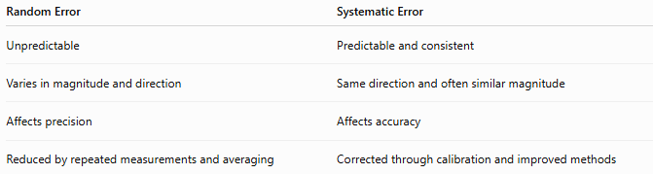
Random Error | Systematic Error
Unpredictable | Predictable and consistent
Varies in magnitude and direction | Same direction and often similar magnitude
Affects precision | Affects accuracy
Reduced by repeated measurements and averaging | Corrected through calibration and improved methods

Random Error vs. Gross Error
# Source: AI Source: Provided by: [Data Path: Persons Table -> ID Column: 1, Name_En Column: Motasem Essam] -> From: [ChatGPT] on [7/17/2026]
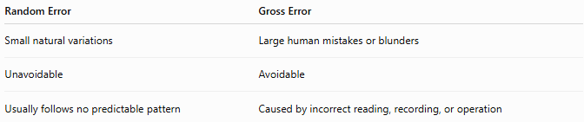
Random Error | Gross Error
Small natural variations | Large human mistakes or blunders
Unavoidable | Avoidable
Usually follows no predictable pattern | Caused by incorrect reading, recording, or operation

Random Error vs. Measurement Uncertainty
# Source: AI Source: Provided by: [Data Path: Persons Table -> ID Column: 1, Name_En Column: Motasem Essam] -> From: [ChatGPT] on [7/17/2026]
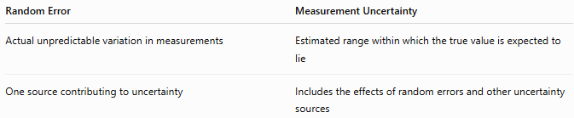
Random Error | Measurement Uncertainty
Actual unpredictable variation in measurements | Estimated range within which the true value is expected to lie
One source contributing to uncertainty | Includes the effects of random errors and other uncertainty sources

Importance
# Source: AI Source: Provided by: [Data Path: Persons Table -> ID Column: 1, Name_En Column: Motasem Essam] -> From: [ChatGPT] on [7/17/2026]
Understanding random errors:
- Improves measurement precision.
- Produces more reliable experimental results.
- Supports statistical analysis.
- Enhances quality control.
- Helps estimate measurement uncertainty.
- Increases confidence in scientific and engineering measurements.

Key Points
# Source: AI Source: Provided by: [Data Path: Persons Table -> ID Column: 1, Name_En Column: Motasem Essam] -> From: [ChatGPT] on [7/17/2026]
- Random errors are unpredictable variations in repeated measurements.
- They mainly affect precision, not accuracy.
- They arise from instrument limitations, environmental changes, observer variations, and natural fluctuations.
- Random errors cannot be eliminated but can be reduced by repeated measurements and averaging.
- Statistical methods such as the mean and standard deviation are commonly used to analyze random errors.

Conclusion
# Source: AI Source: Provided by: [Data Path: Persons Table -> ID Column: 1, Name_En Column: Motasem Essam] -> From: [ChatGPT] on [7/17/2026]
Random Error is an unpredictable measurement error that causes repeated measurements of the same quantity to vary irregularly around the true value. Unlike systematic errors, random errors have no consistent direction or magnitude and primarily affect the precision of measurements. They arise from unavoidable factors such as instrument limitations, environmental fluctuations, observer variability, and natural randomness. Although random errors cannot be completely eliminated, their effects can be significantly reduced through repeated measurements, averaging, improved instruments, controlled conditions, and statistical analysis, leading to more reliable and precise measurement results.

